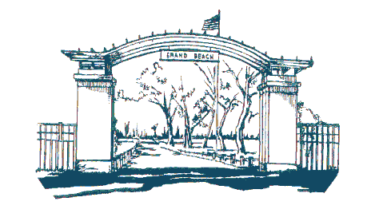
Village of Grand Beach
48200 Perkins Blvd.
Grand Beach, MI 49117

AGENDA FOR BUDGET WORK SESSION

APRIL 6, 2024
8:30 AM EST

- Call to Order

- Adoption of Agenda

- Comments on Agenda Items

- Unfinished Business

- New Business
a. Work Session – Budgeting Discussion Draft Budgets 2024-2025
b. Long Term Strategic Financial Planning

- Public Comments - General

- Correspondence

- Adjournment

